

CG2111A
Engineering Principle and Practice II
Semester 2 2024/2025
“Alex to the Rescue”
Final Report
Team: B02-2A
Name | Student # | Sub-Team | Role
Kynaston Wee Yu Qi | A0307802L | Hardware | Arm Mechanism/Ultrasonic Sensor
Nicholas Lau Hongyi | A0308905B | Software | Lidar/SLAM
Ian Choo Tzie Zheng | A0305936Y | Software | Movement Algorithm
Khoo Junhao | A0307612M | Hardware | Circuit Design/Colour Sensor
Deny Haans | A0308713H | Software | Motor Control

Section 1 Introduction (12 pages, excluding cover, references and appendices)
Introduction
Our ALEX robot is designed to navigate a simulated lunar environment while being remotely controlled by our team. Its primary objective is to map unfamiliar terrain using LIDAR-based navigation, allowing it to detect obstacles and build an accurate representation of its surroundings.
During this mapping process, ALEX will identify astronaut figures based on distinct colour classifications: green indicates astronauts who require minimal medical attention and should be provided with a medpak, while red represents critically injured individuals who must be carefully transported to a designated safe zone.
The robot must operate efficiently, as it is limited to just 8 minutes to complete the mission—both mapping the terrain and rescuing the astronauts. Through the coordinated integration of navigation, mapping, and object recognition, ALEX demonstrates the capabilities of robotic systems in performing critical, life-saving tasks under simulated lunar conditions.

Section 2 Review of State of the Art
2.1 Husky UGV
The Husky UGV is a rugged, four-wheeled robotic platform designed for remote operation and autonomous navigation in challenging environments. It supports various attachments like robotic arms and sensors, including LIDAR for real-time mapping and SLAM-based autonomous path planning. (Clearpath Robotics, n.d.). Controlled via WiFi, radio, or joystick, it operates in areas inaccessible to humans. The hardware features a durable differential drive system and high-capacity batteries for extended use. Its ROS-based software allows easy integration of sensors and advanced navigation.
Strengths | Weaknesses
- Strong LIDAR-based mapping capabilities  - Can integrate a robotic arm for object manipulation.  - Works in remote control (tele-op) and autonomous mode. | - Expensive for commercial applications (~$30,000+)  - Heavy (50 kg), requires a strong power source

2.2 SuperDroid LT2-F
The SuperDroid LT2-F is a tracked tele-operated robot specifically designed for search and rescue missions in disaster-stricken areas. It is built to operate in rough and unstable terrains.
Unlike wheeled robots, the LT2-F utilizes tank-like tracks that provide superior stability and traction, allowing it to move across uneven surfaces, debris, and inclines. (SuperDroid Robots) It is equipped with a robotic arm capable of gripping and manipulating objects and also features an onboard camera, providing a live video feed to the remote operator for improved situational awareness. The LT2-F is primarily controlled via a custom wireless remote control interface, ensuring precise tele-operation even in low-visibility or high-risk environments.
Strengths | Weaknesses
- Tele-operation with high maneuverability in rough terrain  - Integrated robotic arm for object manipulation  - Good power efficiency, operates for extended periods | - Lacks autonomous mapping capabilities unless upgraded with LIDAR  - Lower speed than wheeled robots due to tracked mobility  - Camera feed resolution is limited compared to high-end models

Section 3 System Architecture
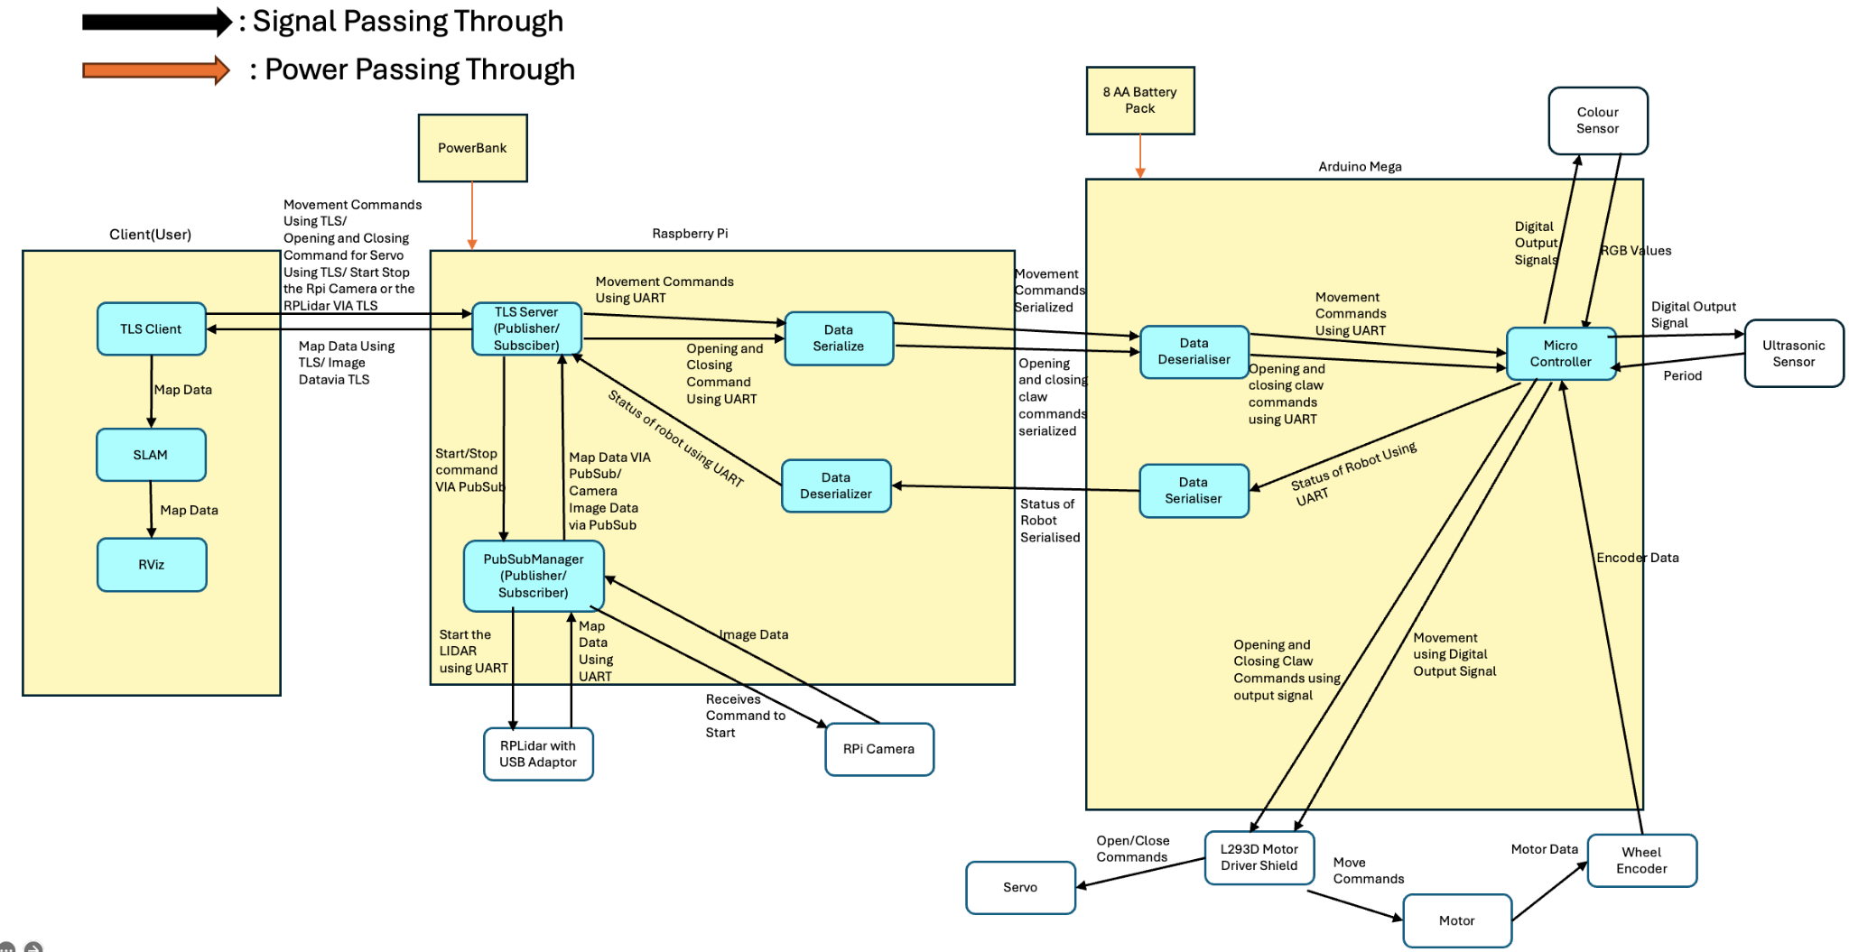
Figure X: System Architecture
Section 4 Hardware Design
4.1 Photographs of the final system
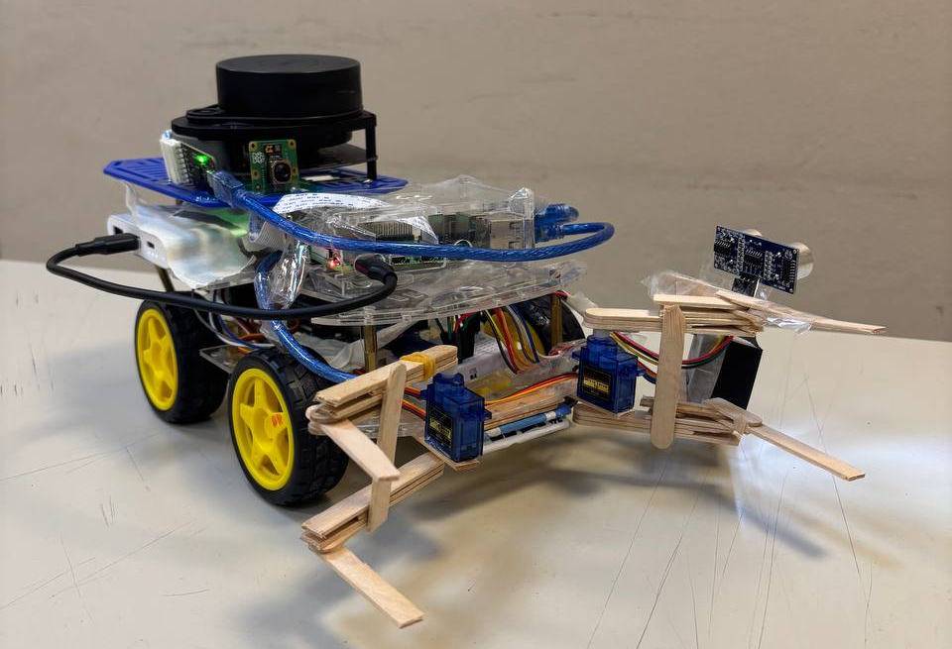
Figure X: Angled view of ALEX
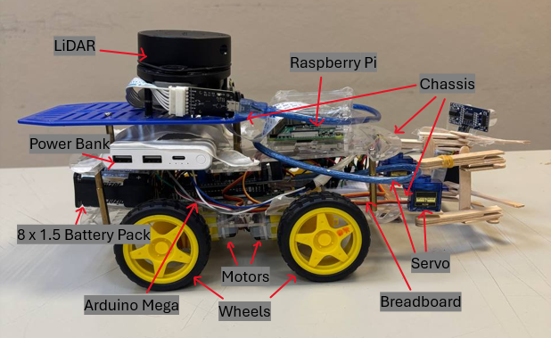  Figure X: Side View of ALEX | 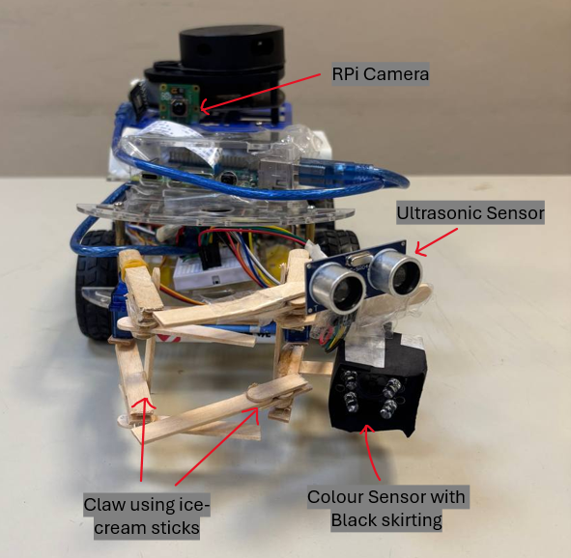  Figure X: Front View of ALEX
4.2 Additional Hardware Features
4.2.1 Ultrasonic sensor
We strategically placed the HC-SR04 Ultrasonic Sensor to the front of ALEX, at the same angle as the color sensor. This ultrasonic sensor will serve two purposes:
- By trial and error, the optimal distance between the ultrasonic sensor and the object to accurately detect the colour of the astronaut is 5 cm. To ensure that when we are using the color sensor, we are always color sensing at the same distance. This will help to ensure accuracy in the colour sensing.
- To be able to know if we are near any obstacles. This is a fail safe option should our RPLiDAR not work optimally. We can send commands continuously via our computer to request for the ultrasonic readings.
4.2.2 Black Paper Skirting
We added a skirting around the colour sensor to block as much ambient light from the colour sensor as possible. This would ensure that the colour sensor detects mainly the light reflected off the astronaut, providing more consistent and accurate readings.
4.2.3 Ice Cream Sticks
Initially, we experimented with a single-claw design, but found that it lacked stability—causing the astronaut figures to occasionally slip or fall during movement. To address this, we implemented a double claw system that alternates when gripping, providing greater stability when handling the astronauts. This design also offers a more secure grip on the medpak, ensuring it remains steady during transportation.
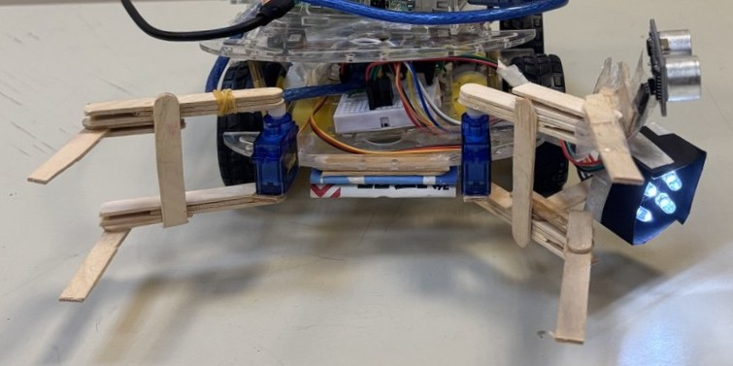  Figure X: Open Claw | 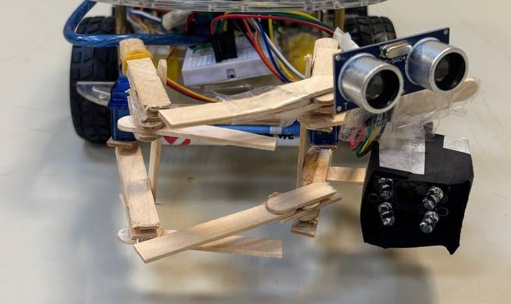  Figure X: Closed Claw
4.2.4 Cardboard
During testing, we noticed that the medpak would sometimes fall through or get stuck beneath the chassis of ALEX due to the limited closure range of our servo. Tightening the servo grip to prevent this would result in grabbing the astronaut too tightly. To resolve this issue, we added a cardboard layer at the base of the robot chassis, which acts as a barrier to prevent the medpak from slipping through the gap—striking a balance between grip strength and functional accessibility.
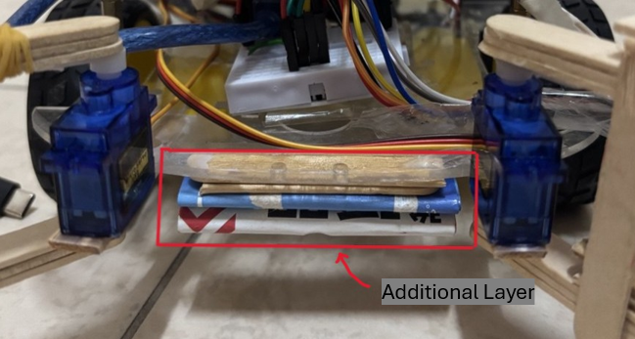
Figure X: Cardboard Layer below the chassis of ALEX

4.2.5 Additional Chassis
We had to make sure that the RPLiDAR would not detect any of the wires or components that we mounted onto ALEX, as this could interfere with detection of surrounding objects. To resolve this, we constructed an additional layer of chassis to place the RPLiDAR, providing it with a clear, unobstructed field of view for reliable scanning and mapping.
This conveniently helped with our navigation using the RPi Camera. With the camera positioned more effectively, we were able to better detect the printed labels on the cans mounted on the astronaut figures (“Coca-Cola” for red and “Sprite” for green), which assisted with accurate victim classification during the rescue mission.

Section 5 Firmware Design
5.1 High level algorithm on the Arduino
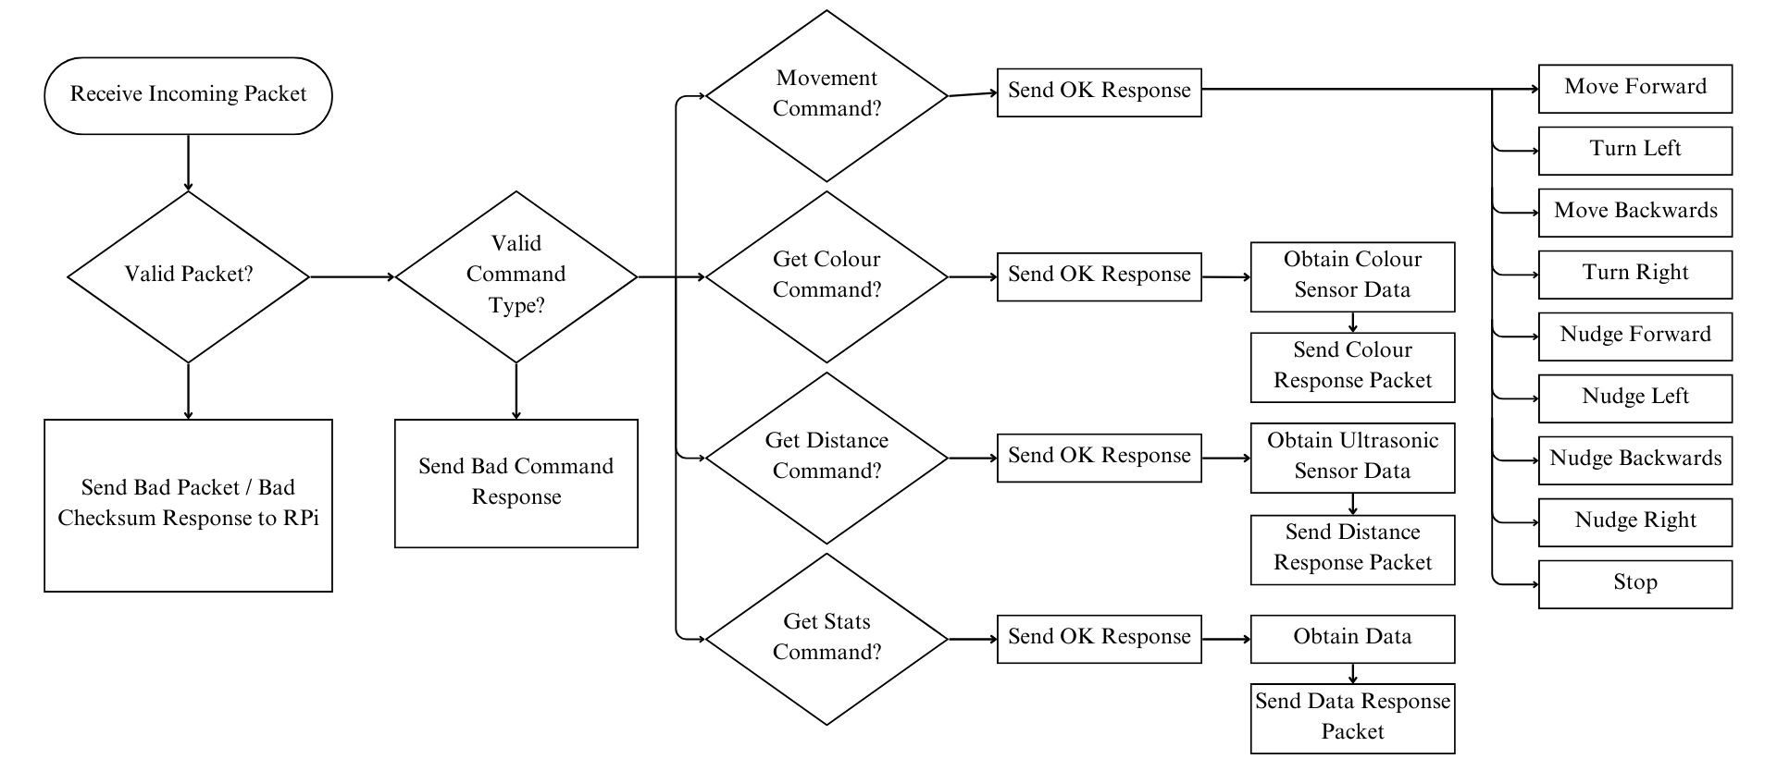
While in serial communication with the RPi, the Arduino will wait for an incoming packet from the RPi. Once the Arduino receives it, it will execute the algorithm shown in Figure 4.
Figure X: High-Level Logic Flowchart for the Arduino
The Arduino will process 3 types of commands:
- Movement
  - It will run motors based on user commands by sending PWM signals to control direction (forward, reverse, left, right, stop)
- Status (Telemetry)
  - The Arduino sends the requested stats of Alex’s data from wheel encoders back to the RPi or clears the stored data.
- Object identification
  - Uses an ultrasonic sensor to measure distances to objects. The measurement is read by the Arduino, whereby the user sends another command to activate the colour sensor.
  - Read color data from the colour sensor to classify objects based on predefined RGB values
  - If we identify a green astronaut, we will drop off a medpak to it. If a red astronaut is identified, we will drag it to a safe zone. Else, we move around the obstacle and continue trying to find the astronauts.
  - Sends object information to the RPi
ALEX will continue with maze navigation, mapping and the rescue mission until it is done.
5.2 Communication protocol (KIV) (format of messages and responses)
5.2.1 Structure and Encoding
Data Transmission: Communication is done over USB serial, using a structured data packet (TPacket) to encapsulate commands and responses.
Packet Format: A TPacket structure is serialised into a byte buffer using a custom serialize() function which is then sent to the Arduino using serialWrite().
void sendPacket(char command) {
char buffet[PACKET_SIZE];
int len = serialize(buffer, packet, sizeof(TPacket));
serialWrite(buffer, len);
}
Each command is identified by a unique command code (e.g., COMMAND_FORWARD). These codes are defined in an enum and processed on the Arduino upon receiving.
5.2.2 Message Flow
From RPi to Arduino:
- The RPi sends serialised TPacket commands for movement, servo control and sensor requests
From Arduino to RPi:
- The Arduino sends back data packets to the RPi, which is then sent to the computer whereby the user is able to view the output.
5.2.3 Baud Rate
The baud rate is set to 115200 to support fast and reliable communication with minimal packet loss. The high baud rate allows for rapid command execution like successive nudges without overwhelming the Arduino’s input buffer and causing a buffer overflow.
5.3 Additional Firmware Features
5.3.1 Streamline Communication
We optimised the packet.h file by changing the size of the params array from params[32] to params[16]. This helped to simplify the packet structure and made data handling smoother and more efficient during serial communication.
#define MAX_STR_LEN 32
// This packet has 1 + 1 + 2 + 32 + 16 * 4 = 100 bytes
typedef struct
{

char packetType;
char command;
char dummy[2]; // Padding to make up 4 bytes
char data[MAX_STR_LEN]; // String data
uint32_t params[16];
} TPacket;
5.3.2 Fixed Speed
Initially, our control system required the user to type out the full command along with speed and distance parameters, which proved to be time-consuming during real-time operation. To improve efficiency, we modified the code to allow robot movement to be triggered with a custom single key press. Each key press corresponds to a fixed movement, where the travel distance is determined by a predefined delay followed by an automatic stop of the motor.
void move(float speed, int direction)
{
int speed_scaled = (75 / 100.0) * 255;
motorFL.setSpeed(speed_scaled);
motorFR.setSpeed(speed_scaled);
motorBL.setSpeed(speed_scaled);
motorBR.setSpeed(speed_scaled);

switch (direction)
{
case GO:
motorFL.run(BACKWARD);
motorFR.run(FORWARD);
motorBL.run(BACKWARD);
motorBR.run(FORWARD);
delay(300);
motorFL.run(RELEASE);
motorFR.run(RELEASE);
motorBL.run(RELEASE);
motorBR.run(RELEASE);
break;
}
void forward(float speed)
{
dir = (TDirection) FORWARD;
move(speed, GO);
}

Section 6 Software Design
6.1 High level algorithm on the Pi
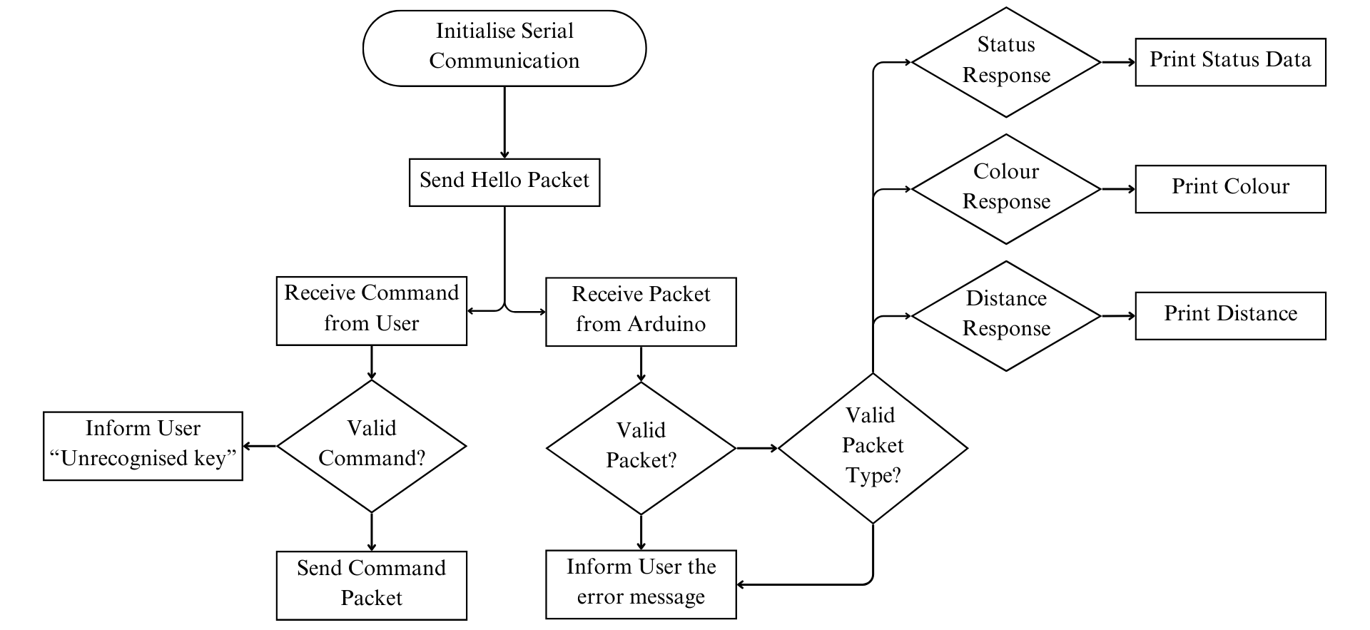
Figure X: High-Level Logic Flowchart for the Raspberry Pi
6.1.1 Teleoperation
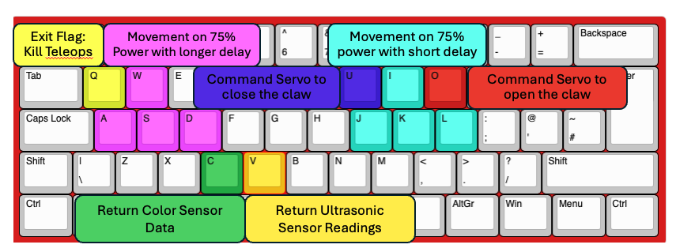
Figure X: Visual Representation of Keybindings used for Teleoperation
To send the commands via the TLS server, our designated driver inputs the keybinds without the need to press the enter key. This was done using the getch() command.
char getch() {
struct termios oldt, newt;
char ch;

// Get current terminal settings
tcgetattr(STDIN_FILENO, &oldt);
newt = oldt;

// Disable echo and buffering
newt.c_lflag &= ~(ICANON | ECHO);

// Apply new settings
tcsetattr(STDIN_FILENO, TCSANOW, &newt);

// Read one character
read(STDIN_FILENO, &ch, 1);

// Restore old settings
tcsetattr(STDIN_FILENO, TCSANOW, &oldt);

return ch;
}

6.1.2 Color detection
Sensor Integration: A colour sensor is mounted on the robot and connected to the Arduino. It reads RGB values of the object that it is detecting, based on the reflectivity of the colour.
Classification Algorithm: Pre-testing of the colours was done to determine the rough RGB values of the Red and Green astronauts. The RPi receives the RGB values and uses a K-Nearest Neighbours (KNN) approach to determine the colour of the object.
Detection Flow: A command is sent from the RPi to the Arduino requesting a colour reading. The Arduino collects RGB values via the colour sensor. These values are sent to the RPi as a response packet.The Raspberry Pi runs a K-Nearest Neighbours (KNN) classification algorithm using predefined training data (e.g., Sprite for green, Coca-Cola for red). Based on the classification, the robot either delivers a medpak or transports the object to the safe zone. These tasks are done via the servo placed at the front of ALEX.
6.2 Additional Software Features
6.2.1 Serial Communication Optimization
We adjusted the baud rate from 9600 to 115200 to significantly reduce bad packet errors caused by buffer overflow during high-frequency data transmission. This optimization was crucial for sending nudge commands rapidly and reliably, especially when operating within tight time constraints. By reducing the delay between commands, we achieved more responsive and precise control of the robot during critical movements.
6.2.2 Centralised Command Access
To streamline control during operation, we mapped all key functionalities—including the color sensor, servo motor, and ultrasonic sensor readings— to a specific key on the keyboard. This simplified the user interaction layer and made it easier for the operator to execute commands quickly.

6.2.3 Custom Display Configuration of Robot
We modified the default lidar_display.py to reflect the actual length and breadth of our robot on the LiDAR and SLAM map. This change allowed us to more accurately visualize the robot's position relative to obstacles within the environment. It became a key quality-of-life enhancement for the operator, who could now estimate proximity to obstacles visually—without relying solely on ultrasonic readings or LiDAR data—making the navigation process more intuitive and less prone to error.
6.2.4 LiDAR Noise Filtering and Scan Rate
Initially, the LiDAR produced a lot of noise, which introduced uncertainty during navigation in the maze. To improve the accuracy of obstacle detection, we lowered the MAP_QUALITY parameter. This allowed the mapping algorithm to ignore small fluctuations that were likely due to noise, improving the overall clarity of the map.
We also increased the SCANNING_FREQUENCY, allowing the LiDAR to perform scans more rapidly. This provided more up-to-date information about the environment, especially helpful in tight or complex turns where precise obstacle positioning was critical.
6.2.5 Faster Obstacle Detection for SLAM
Given that the obstacle course contained stationary objects, we optimized SLAM parameters to prioritize quicker detection. We reduced the MIN_SAMPLES value so that the system would require fewer data points to confirm the presence of an object. This helped the map update faster and allowed the robot to react more promptly to obstacles.

6.2.6 Improved Object Joining for SLAM
We also reduced the HOLE_WIDTH_MM parameter, which controls how close detected points must be to be considered part of the same object. By decreasing this threshold, nearby points were joined together more readily, improving the robot’s ability to represent clustered obstacles as continuous shapes rather than scattered dots. This enhanced the reliability of path planning and improved the consistency of the SLAM-generated map.

Section 7 Lessons Learnt
7.1 Two Most Important Lessons Learned
7.1.1 Embracing Iteration and Feedback
Throughout the project, we adopted an iterative approach, continuously refining our robot through repeated cycles of trial and error. This ranged from hardware improvements—such as evolving from a single to a double claw design for improved grip stability—to software adjustments like tuning SLAM parameters and filtering out LiDAR noise. We also took inspiration from our peers’ designs, learning from their ideas and applying relevant strategies to our own robot.
Although the iteration process was often time-consuming and mentally draining, it ultimately became one of the most rewarding aspects of our journey. We learned that effective design is rarely perfect from the start—it’s a process of constant learning, reevaluation, and thoughtful revision. Even when we thought something was “complete,” we discovered there was always room for improvement. Embracing this iterative mindset proved crucial to our robot’s ability to meet and exceed the mission’s objectives.
7.1.2 Small Technical Tweaks Make Big Differences
One of the most eye-opening lessons from this project was realizing how small technical adjustments—whether in hardware or software—could lead to major performance gains. For example, increasing the baud rate reduced data loss and enabled faster, more reliable command transmission. Fine-tuning SLAM parameters like MIN_SAMPLES and HOLE_WIDTH_MM improved obstacle detection speed and accuracy, while updating the LiDAR display to match our robot’s dimensions enhanced spatial awareness and navigation.
These deliberate changes had a cumulative impact that significantly boosted our robot’s efficiency and stability. The experience underscored the value of systematic troubleshooting and a detail-oriented mindset. It also taught us resilience and patience—learning to stay calm, keep experimenting, and trust that progress comes step by step.

7.2 Two Greatest Mistakes Made as a Group
7.2.1 Initial Oversight of Hardware Interference
Mounting components without first considering how they might obstruct the LiDAR field of view was a significant hurdle. It led to added work redesigning mounts and repositioning sensors. It highlights how important it is to think holistically about hardware layout from the start, especially for sensor-based robots.
7.2.2 Insufficient planning for the run
During our trial run, a lack of proper planning and team practice led to several impromptu decisions that negatively affected our performance. Without prior coordination, our team chemistry was inconsistent, which quickly became evident during the run. Although we began with high confidence—having successfully tested all individual components—the absence of rehearsals resulted in miscommunication, panic, and shouting between the LiDAR observer and the driver. This confusion led to critical mistakes, such as getting the robot stuck in a corner and failing to notice that it was completely immobilized, ultimately preventing us from completing the maze.
After reflecting on our performance and consulting other teams about their strategies, we revised our approach. We assigned a single person to both monitor the LiDAR and SLAM map and control the robot via keyboard commands. This significantly reduced the need for communication between team members and improved our navigation efficiency.
For the final run, we chose the team member most proficient at operating ALEX to take control, while the rest of the team focused on supporting other system components. This streamlined coordination led to a more effective and cohesive performance.

References
Clearpath Robotics. (n.d.). Husky UGV – Unmanned Ground Vehicle Robot. Retrieved from https://clearpathrobotics.com/husky-a300-unmanned-ground-vehicle-robot
SuperDroid Robots. (n.d.). LT2-F Tactical Search & Rescue Robot. Retrieved from https://www.superdroidrobots.com/tactical-robots/tactical-lt2-f-bulldog

Appendix: Images for Section 2
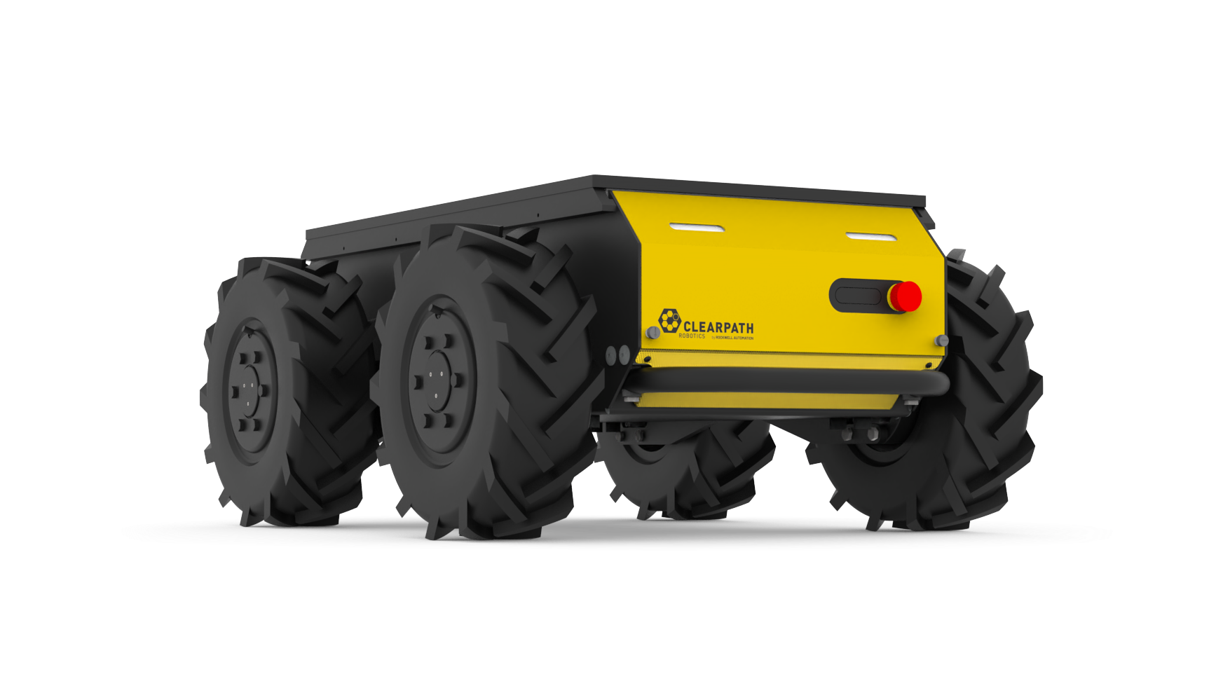
Figure X: Image of Husky UGV
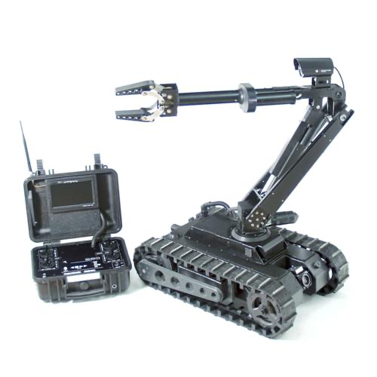

Figure X: Image of Superdroid LT2-F

